LAB 2
Mayon Francis
CS3A 44

Program 1
Write a JAVA program that checks whether a given string is a palindrome or not
Input: String read from keyboard
Output: Message displayed

//Palindrome
import java.util.Scanner;

public class Palindrome {
public static void main( String args[] ) {

Scanner sc = new Scanner(System.in);
System.out.println("Enter a string");
String usrInput = sc.nextLine();
int len = usrInput.length();
int flag = 1;
for(int i=0; i<(len/2); i++) {
if( !(usrInput.charAt(i) == usrInput.charAt(len-1-i) ) ) {
flag = 0;
break;
}
}
if( flag == 1)
System.out.println("This is a palindrome");
else
System.out.println("This is not a palindrome");
}
}
OUTPUT
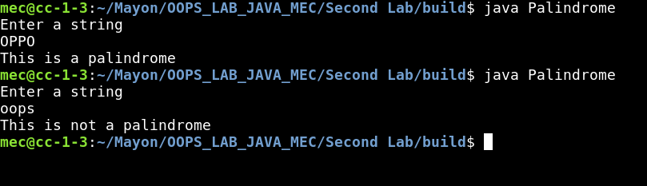

Program 2
Write a Java program to find the frequency of given character in a string.
Input: String read from keyboard
Character read from keyboard.
Output: Number of occurrences of the character in the string

//CharFrequency
import java.util.Scanner;

public class CharFrequency {
public static void main( String args[] ) {

String usrInput;
char ch;
int len, freq = 0;
Scanner sc = new Scanner(System.in);
System.out.println("Enter a string");
usrInput = sc.nextLine();
System.out.println("Enter a character");
ch = sc.next().charAt(0);

len = usrInput.length();
for(int i=0; i<len; i++) {
if( ch == usrInput.charAt(i) ) {
freq++;
}
}
System.out.println("\"" + ch + "\" Occurs " + freq + " times in : \"" + usrInput + "\" ");

}
}

OUTPUT

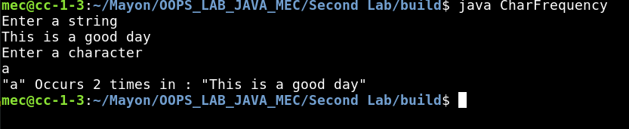

Program 3

Write a Java program to multiply two given matrices.
Input: Dimensions of two matrices (MxN, PxQ)
: If dimensions are suitable for multiplication, read two integer matrices, say A and B
Output: Matrices A, B and C = A*B displayed / Error message

//Matrix Multiplication
import java.util.Scanner;

public class matrixMult {
public static void main( String args[] ) {

int m, n, p, q;
int A[][], B[][], C[][];
Scanner sc = new Scanner(System.in);
System.out.println("Enter a No. of rows of matrix A");
m = sc.nextInt();
System.out.println("Enter a No. of columns of matrix A");
n = sc.nextInt();
System.out.println("Enter a No. of rows of matrix B");
p = sc.nextInt();
System.out.println("Enter a No. of columns of matrix B");
q = sc.nextInt();

if( n!= p ) {
System.out.println("Matrices are incompatible for multiplication! \n Exiting.");
System.exit(0);
}
A = new int[m][n];
B = new int[p][q];
C = new int[m][q];

System.out.println("Enter a matrix A row wise");
getMatrix(A, m, n);
System.out.println("Enter a matrix B row wise");
getMatrix(B, p, q);

System.out.println("Matrix A :");
printMatrix(A, m, n);
System.out.println("Matrix B :");
printMatrix(B, p, q);

multMatrix( A, n, m, B, p, q , C);

System.out.println("A mult by B :");
printMatrix(C, m, q);

}

static void getMatrix( int Arr[][], int m, int n ) {
Scanner sc = new Scanner(System.in);
for (int i=0; i<m; i++) {
for (int j=0; j<n; j++) {
Arr[i][j] = sc.nextInt();
}
}
}

static void printMatrix( int Arr[][], int m, int n ) {
for (int i=0; i<m; i++) {
for (int j=0; j<n; j++) {
System.out.print(Arr[i][j] + " ");
}
System.out.println();
}
}

static void multMatrix( int Arr1[][], int n, int m, int Arr2[][], int p, int q , int out[][]) {
for (int i=0; i<m; i++) {
for (int j=0; j<q; j++) {
for ( int k=0; k<n; k++) {
out[i][j] = out[i][j] + Arr1[i][k] * Arr2[k][j] ;
}
}
}
}
}

OUTPUT
